

BSc (Hons) Computing Systems

FINAL REPORT

ON

Online Doctor’s Appointment System

Student Name: Pradip Chettri
Student Number:
Project Supervisor Name: Iftikhar Afridi
Date: 2022/2023

Abstract
During the COVID-19 pandemic, visiting hospitals for doctor's counselling sessions became a significant challenge. The Online Doctor Appointment System (ODAS) was developed to address this issue by facilitating the management of various appointments through a web-based platform. This system offers doctor consultations, recommendations, and the ability for patients to request appointments remotely. ODAS serves as an example of telehealth and remote medicine.
The Online Doctor Appointment System boasts a user-friendly graphical interface, making it easy and intuitive for users. It also prioritizes data security to protect the sensitive information of both doctors and patients. The platform saves time and enhances transparency by streamlining the appointment booking process and fostering effective communication between doctors and patients.
One of the notable features of ODAS is the integration of a chatbot. This AI-powered chatbot assists users in identifying the appropriate medical specialist based on their symptoms. By inputting their symptoms, users receive recommendations on which type of specialist to consult, further streamlining the process of finding the right healthcare professional.
ODAS enables seamless interactions among administrators, doctors, and patients, catering to various aspects of the healthcare system. By promoting remote counselling and consultations, the system reduces the need for in-person visits, alleviating the pressure on healthcare facilities during the pandemic and providing a more convenient option for patients and healthcare professionals alike. The addition of the chatbot feature enhances the user experience, making it even more efficient for patients to access the care they need.

Keywords: Online Doctor Appointment System (ODAS), Remote appointments, Chatbot, Availability

Acknowledgements

It is with immense gratitude and humility that I express my sincerest appreciation to everyone who has supported and assisted me in this journey. I am particularly grateful to Mr. Iftikhar Afridi, whose expert guidance, invaluable insights, and unwavering encouragement have played a crucial role in the completion of this report. Despite his busy schedule, he consistently made time to review my work, and his continuous inspiration has motivated me to achieve my objectives.
I would also like to express my profound gratitude to the esteemed faculty of Computing Engineering for their unwavering support, invaluable knowledge, and dedication to my education. This opportunity to work on such a meaningful project would not have been possible without their guidance and commitment to my growth. Furthermore, I extend my heartfelt thanks to my friends and colleagues who have contributed their time, energy, and expertise to help me bring this project to fruition. Their camaraderie, tireless efforts, and collaborative spirit have been instrumental in overcoming the challenges I faced along the way.
In addition, I would like to acknowledge the role of my family in providing me with unwavering support, love, and encouragement throughout this journey. Their faith in my abilities and their constant reminders of my potential have been essential in keeping me motivated and focused. Lastly, I recognize that this project is a culmination of the combined efforts of countless individuals, and I am deeply grateful for the opportunity to learn from and collaborate with such an incredible community. As I move forward, I will carry the knowledge, experience, and gratitude gained from this project with me, and I hope to continue making meaningful contributions to the field of Computing Engineering.

Table of Contents

Abstract 2
Acknowledgements 3
Table of Contents 4
List of Figures 6
Chapter 1: Introduction 7
1.1. Background 7
1.2. Project Aims 8
1.3. Project Objectives 8
1.4. Structure of Report 8
Chapter 2: Literature Review 13
2.1. Background of Study 13
2.2. Study of Existing System 14
2.3. Software Development life cycle: 16
2.3.1 The waterfall model 17
2.3.2 Agile Model 18
2.3.3 Prototyping Model 19
2.3.4 Spiral Model 20
Chapter 3: Technical background 22
3.1. Hardware Components: 22
3.2. Software: 22
3.3. Programming languages: 23
3.4. PyCharm Code editor 23
3.5. Databases 24
3.6. Draw.io 24
3.7. Git and GitHub 25
Chapter 4: Requirements 26
4.1. Functional Requirements 26
4.2. Non-Functional Requirements: 26
4.3. Data Protection: 26
Chapter 5: Design 28
5.1. System Flowchart for Registering Users 28
5.2. Login Process 29
5.3. Booking Process 30
5.4. Chatbot Interaction 31
5.5. Interface Design 32
Chapter 6: Project Planning 40
6.1. Resource Consideration 40
6.2. Risk Assessment 41
6.3. Risk mitigations: 41
6.4. Gant chart 43
6.5. Work Breakdown Structure 45
Chapter 7: Implementation of the system 46
7.1. Working process of the project 46
Chapter 8: Testing and Evaluation 48
8.1. Test case 1: 48
8.2. Test Case 2: 49
8.3. Test Case 3: 50
8.4. Test Case 4: 52
8.5. Test Case 5: 53
8.6. Test Case 6: 55
8.7. Test case 7: 55
Chapter 9: Conclusion and future Recommendations 57
9.1. Critical analysis 57
9.2. Future Enhancements 58
References 59

List of Figures
Figure 1: Waterfall Model 17
Figure 2 : Agile Model 18
Figure 3: Prototyping Model 19
Figure 4: Spiral Model 20
Figure 5 : System Flowchart for registering users 28
Figure 6: Flowchart Showing Login process 29
Figure 7: Flowchart showing booking process 30
Figure 8: Flowchart showing Chatbot Interaction. 31
Figure 9: wireframe of Home Page 32
Figure 10: wireframe of main menu 33
Figure 11: Wireframe of Login page 34
Figure 12: wireframe List of Doctors page 34
Figure 13: Wireframe of Doctor’s Details page 35
Figure 14: Wireframe for Booking page 36
Figure 15: Wireframe for Profile page 37
Figure 16: Wire Frame of Availability Page 38
Figure 17: Wireframe of Chatbot Page 39
Figure 18: Table Showing Risk Mitigation Strategy 43
Figure 19: Gantt Chart 44
Figure 20: Image showing Time Schedule 45
Figure 21: Image showing the work breakdown structure 45
Figure 22: Test case 1 result 49
Figure 23: Test case 2 result 50
Figure 24: Test case 3 Result 1 51
Figure 25: Test case 3 Result 2 51
Figure 26 : Test case 4 Result 1 52
Figure 27: Test case 4 Result 2 53
Figure 28: Test case 5 Result 1 54
Figure 29: Test case 5 Result 2 54
Figure 30: Test case 5 Result 3 54
Figure 31: Test case 6 Results 55
Figure 32: Test case 7 result 56

Chapter 1: Introduction

Background
The COVID-19 pandemic has highlighted the critical need for remote healthcare solutions, and the Online Doctor Appointment System (ODAS) is a pioneering platform that aims to revolutionize the way patients access medical care. By providing a seamless and convenient way to consult with healthcare professionals from the comfort of their homes, ODAS caters to the needs of patients in remote areas with limited access to healthcare facilities, while also addressing the challenges posed by the pandemic [1].
One of the key features of this platform is its real-time appointment scheduling system, which displays doctors' availability, streamlining the appointment process and minimizing scheduling conflicts. This user-friendly feature allows patients to book appointments at their convenience, ensuring a hassle-free experience for both patients and healthcare professionals.
Furthermore, ODAS integrates a secure patient portal, which provides users with a centralized repository for managing their personal information. This feature ensures that both patients and doctors have easy access to relevant data during consultations, facilitating a more personalized and effective healthcare experience.
Through the integration of cutting-edge technologies and a user-centric design, ODAS is positioned to transform the healthcare landscape by providing patients with unparalleled access to medical care, regardless of their location or circumstances. The platform is designed to promote greater healthcare equity and improve the overall quality of life for individuals across the globe.
In conclusion, the Online Doctor Appointment System is a sophisticated and innovative platform that represents a significant step forward in the evolution of healthcare. By empowering patients with greater control over their healthcare experience and providing healthcare professionals with a powerful tool for delivering high-quality care, ODAS is poised to make a profound impact on the healthcare industry and improve the lives of people around the world [2].

Project Aims
The objective of this project is to create, test, and assess an Online Doctors appointment system that expedites the process of booking appointments from home. Additionally, the system includes a Chatbot feature that recommends specialists based on user symptoms. The utilization of Django and Google SMTP streamlines the appointment booking process, eliminating the need for hospital visits.

Project Objectives
The primary objective of the project is to develop a comprehensive web-based application that can efficiently manage appointments in the front-end section and store data securely in the back-end section. The platform must have a robust analysis and design to ensure that it can effectively meet the needs of patients and healthcare professionals.
The secondary objectives of the project are equally important and aim to address the challenges faced by the current healthcare system. They include:
1. Collecting and storing accurate information about patients and doctors in a secure database that can be easily accessed by authorized personnel, enabling them to provide personalized and effective healthcare services.
2. Facilitating real-time availability of doctors to ensure that patients can book appointments at their convenience and minimize scheduling conflicts.
3. Email Confirmations, Reminders.
4. Recommending specialists based on user’s symptoms via a chatbot.
Overall, the project aims to revolutionize the healthcare industry by leveraging the latest technologies and best practices to improve access to medical care, enhance patient outcomes, and promote greater healthcare equity.

Structure of Report
The report will take the following structure:
Chapter 2 – Literature Review
This chapter explores the evolution of telehealth, tracing its roots from transmitting radiographic images through telephone lines to the advanced telehealth solutions available today due to the internet and digital technologies. The focal point is the Online Doctor Appointment System (ODAS), a revolutionary platform built using Python and Django. ODAS aims to transform healthcare access by offering a streamlined appointment scheduling process, secure patient portals, and an AI-powered chatbot for assistance. The combination of Python and Django brings forth numerous benefits such as readability, productivity, scalability, and security, making them well-suited for a project like ODAS. By leveraging these technologies, ODAS strives to enhance remote healthcare access and improve the overall quality of life for individuals worldwide.
Chapter 3 – Technical Background
In the chapter on technical context, an overview of the required technology and infrastructure for an online doctor’s appointment system is provided. This chapter discusses the various components of the system, including the hardware, and software, as well as the technical specifications for each. It also discusses the various framework, such as Django and Google smtp. In addition, the chapter describes the programming languages, databases (such as Python, Django and SQLite3) that were used to construct the system. Overall, the technical foundation chapter provides comprehensive information about the technology and infrastructure required for a system to function.
Chapter 4 – Requirements
The requirements section outlines the necessary functionalities of an online doctor’s appointment. This chapter focuses on discussing these functional requirements, including tasks such as user login, registration, interactions with the chatbot, and doctor appointment booking. Additionally, it addresses system efficacy, reliability, and security, which are crucial aspects but not directly related to system functionality. The chapter also explores user requirements, emphasizing the importance of user-friendly interfaces for both patients and staff, as well as comprehensive reporting capabilities for administrators. Furthermore, it highlights any legal or regulatory requirements, such as data privacy regulations, that the system must adhere to. Overall, this chapter provides a clear understanding of the expected functionality and requirements of the Online Doctors Appointment system.
Chapter 5 – Design
The design section presents a comprehensive overview of the system's overall design. This chapter focuses on describing the architectural design, encompassing both the hardware and software components and their interactions. The user interface design, including features like registration, login, booking, and chatbot interaction, is also outlined. Various design patterns, such as the Model-View-Controller (MVC) pattern, are examined in relation to their contributions to the system's functionality and performance. Additionally, the chapter discusses the testing and validation techniques employed to ensure that the system aligns with the requirements outlined in Chapter 4. By providing this detailed insight, the design chapter offers a thorough understanding of the development and design aspects of an online doctor’s appointment
Chapter 6 – Project Planning
The project planning chapter outlines the development project plan for the facial recognition attendance system. It encompasses various aspects such as the project's scope, goals, and objectives. The chapter provides a summary of the schedule and timeline for the project, ensuring timely completion. It defines the organization of the project team, including the roles and responsibilities of each team member, fostering clear communication and collaboration. Risk management strategies are analysed, including risk identification and mitigation, ensuring potential obstacles are addressed proactively. The chapter also details the quality management plan, encompassing quality assurance and control procedures throughout the project. Additionally, it covers the project's budget and resource allocation, ensuring effective utilization of resources. Overall, the chapter establishes a systematic and precise approach to the development of the Online Doctor's Appointment system, ensuring timely delivery within budget and meeting the desired quality standards.
Chapter 7 – Implementation
The implementation chapter focuses on the construction and deployment of the Online Doctor's Appointment system. It covers various aspects, including the implementation of hardware and software components. This involves tasks such as installing and configuring the Django Framework and other hardware devices, as well as developing and integrating software modules. The chapter also addresses testing and validation, including the evaluation of different scenarios and use cases to ensure system performance and accuracy. Deployment of the system is discussed, including the installation and configuration process at the designated location, as well as the training and support provided to system users. The chapter provides a comprehensive understanding of the construction, testing, and deployment phases of the Online Doctor's Appointment system, along with insights into the major challenges and achievements encountered throughout the implementation process.

Chapter 8 – Testing and Evaluation
The testing and evaluation chapter focuses on the procedures implemented to test and evaluate the an online doctor’s appointment. It discusses various testing techniques, such as functional testing, performance testing, and security testing, providing the results obtained from each test. The evaluation of the system against the standards defined in Chapter 4 is also covered, including assessments of precision, efficiency, and utility. The chapter explores user and stakeholder feedback, detailing how it was incorporated to improve the system. It concludes with a discussion on the limitations of the testing and evaluation methodologies employed and suggests areas for future research and development.
The outcomes and successes of the Online Doctor's Appointment system project are detailed in the results chapter. It examines the system's efficacy, precision, and the extent to which the project's goals and objectives were achieved. The report addresses the system's usability, user acceptance, and overall effectiveness in meeting the requirements outlined in Chapter 4. Statistical data and graphical representations are provided to compare the system's performance and utilization with the initial project goals and objectives. The chapter also discusses any limitations or obstacles encountered during the project and how they were resolved. Overall, the results chapter provides a comprehensive analysis of an online doctor’s appointment project's outcomes and achievements, along with insights into the potential advantages and challenges associated with implementing the Online Doctor's Appointment system.
Chapter 9 – Conclusion and future recommendations
The conclusion chapter offers a comprehensive summary of the Online Doctor's Appointment System (ODAS) project and its key outcomes. It highlights the significant achievements and results obtained throughout the project, emphasizing their contributions to reshaping healthcare access and improving the overall quality of life for individuals worldwide.
The chapter discusses the successful implementation of ODAS, including the streamlined appointment scheduling process, secure patient portals, and AI-powered chatbot assistance. It reflects on how ODAS has addressed the challenges of remote healthcare access, particularly during the COVID-19 pandemic, by providing a convenient and efficient platform for booking doctor appointments from home.
Furthermore, the conclusion chapter acknowledges any limitations or obstacles encountered during the project and discusses potential avenues for future research and development. It reflects on the project's impact and how it has contributed to advancing the field of online healthcare systems, particularly in terms of leveraging Python, Django, and AI technologies.
The chapter concludes by highlighting the broader benefits of ODAS, such as improved healthcare accessibility, patient empowerment, and the potential for reducing healthcare costs. It emphasizes the significance of ODAS in enhancing the healthcare experience for patients and healthcare professionals alike.
Overall, the conclusion chapter provides a comprehensive summary of the ODAS project, its achievements, limitations, and future prospects, showcasing its potential to revolutionize the way individuals access and experience healthcare services.

Chapter 2: Literature Review

Background of Study
The concept of telehealth, or using technology to enable remote healthcare, dates back to the early 20th century, with the transmission of radiographic images via telephone lines. Telemedicine evolved further during the 1950s and 1960s with the advent of television and telephone, enabling real-time consultations. The widespread adoption of the internet and digital technologies in the late 20th and early 21st centuries paved the way for modern telehealth solutions, allowing for the transmission of medical data, images, and videos, and offering various healthcare services, such as remote consultations, monitoring, and diagnostics, to patients worldwide [3].
The Online Doctor Appointment System (ODAS) is a ground-breaking platform designed to reshape the way patients access medical care, especially during challenging times like the COVID-19 pandemic. Developed using the versatile Python programming language and the Django web framework, ODAS offers a streamlined appointment scheduling process, secure patient portals, and AI-powered chatbot assistance, providing a user-centric and efficient healthcare experience.
Python's clear and concise syntax promotes readability and simplicity, which boosts productivity and facilitates collaboration among developers. Django, an open-source web framework for Python, enables rapid development and adheres to the "Don't Repeat Yourself" (DRY) principle. It offers numerous built-in tools, libraries, and modules that allow developers to create fully functional web applications with minimal code [4].
Python and Django provide scalability and flexibility, making it easy to manage growing user bases and evolving requirements. Django's modular architecture allows for seamless component addition, modification, or removal, making it ideal for projects like ODAS that may require future updates or enhancements. Both Python and Django boast large, active communities that contribute to the improvement of the language and framework. This ensures that developers have access to extensive documentation, tutorials, and forums for troubleshooting and staying current with best practices.
Django's built-in security features protect web applications from common security threats such as cross-site scripting (XSS), cross-site request forgery (CSRF), and SQL injection. This is particularly vital for a platform like ODAS, which handles sensitive patient data. Python's popularity for AI and machine learning applications simplifies the integration of the chatbot feature in ODAS, leveraging the extensive libraries and tools available to build and optimize the chatbot [5].
By harnessing the power of Python, Django, and cutting-edge AI technologies, ODAS provides a sophisticated and innovative solution to address the challenges of remote healthcare access. The platform empowers patients and healthcare professionals with greater control over their healthcare experiences while promoting greater healthcare equity and improving the overall quality of life for individuals worldwide [6].

Study of Existing System
A literature review was conducted to explore the use of remote healthcare solutions, specifically Online Doctor Appointment Systems (ODAS). The review focused on existing ODAS platforms and examined their strengths and limitations. Based on the findings, a framework was developed for designing an ODAS platform that utilizes cutting-edge technologies and user-cantered design principles.
- Existing System: National Health Service (NHS)
The NHS website uses technologies like PHP, Python, JavaScript, HTML, CSS, MySQL, and PostgreSQL. It was created to provide comprehensive healthcare to all UK citizens, regardless of socio-economic background [7]. However, the NHS faces challenges such as long waiting times, overburdened staff, and difficulty in accessing specialist care.
Problems: Long waiting times, overburdened staff, and difficulty in accessing specialist care. Missing appointments due to no reminders.
Proposed Solution (ODAS): The ODAS, integrated with a chatbot, will streamline the process of connecting patients with the right healthcare provider based on symptoms, reducing waiting times. It will manage doctor availability in real-time, avoiding overbooking and relieving the administrative burden. The email reminders will also help patients not forget their consulting dates.
Existing System: MyChart
MyChart is a widely-used patient portal that enables patients to schedule appointments, access medical records, and communicate with healthcare providers. The platform is built using .NET, C#, and SQL Server and is available in many healthcare systems in the United States, but it is also utilized in some UK healthcare systems [8].
Problems: Lack of personalized recommendations for specialists and limited real-time availability information for doctors.
Proposed Solution (ODAS): ODAS integrated with a chatbot will provide personalized recommendations based on user symptoms, ensuring timely and appropriate care. It will also provide real-time doctor availability information, improving the scheduling process and reducing waiting times.
- Existing System: GP at Hand
GP at Hand is a UK-based digital health service that offers video consultations with NHS doctors via a smartphone app. The platform is built using technologies like React Native, Node.js, and MongoDB. While GP at Hand has helped address issues such as access to care and appointment scheduling [9].
Problems: Challenges in providing personalized specialist recommendations and managing doctor availability effectively.
Proposed Solution (ODAS): ODAS will enhance user experience by providing personalized specialist recommendations based on patient symptoms. It will improve doctor availability management through its real-time detection feature. It will also provide personalized email confirmations and reminders.
- Existing System: eConsult
eConsult is a digital platform used by several UK general practices to facilitate online consultations between patients and their healthcare providers. The platform is built using technologies such as PHP, Laravel, and MySQL. eConsult enables patients to submit an online form detailing their symptoms and concerns [10].
Problems: No personalized specialist recommendations or real-time doctor availability information.
Proposed Solution (ODAS): ODAS will offer personalized specialist recommendations and real-time doctor availability information, improving patient care and reducing waiting times. The email confirmation/reminders will also be very beneficial for the patients .

- Existing System: Push Doctor
Push Doctor is a UK-based telemedicine platform that allows patients to have video consultations with doctors via their website or mobile app. The platform uses technologies like PHP, JavaScript, and MySQL [11].
Problems: No personalized specialist recommendations or real-time doctor availability information.
Proposed Solution (ODAS): ODAS will provide personalized specialist recommendations and real-time doctor availability information, enhancing patient care and the scheduling process. It will also provide personalized email confirmations and reminders.
- Existing System: Doctorlink
Doctorlink is a UK-based digital health platform that provides patients with access to online symptom assessments, appointment booking, and video consultations. The platform uses technologies like Node.js, AngularJS, and MongoDB [12].
Problems: Challenges in providing personalized specialist recommendations and managing real-time doctor availability effectively.
Proposed Solution (ODAS): ODAS will improve patient care by providing personalized specialist recommendations and real-time doctor availability information, enhancing the scheduling process and reducing waiting times.
Existing System: LIVI
LIVI is a UK-based telehealth platform that connects patients with healthcare professionals through video consultations. The platform is built using technologies such as React Native, Node.js, and MongoDB [13].
Problems: No personalized specialist recommendations or real-time doctor availability information.
Proposed Solution (ODAS): ODAS will provide personalized specialist recommendations and real-time doctor availability information, improving patient care and reducing waiting times.

- Existing System: Qured
Qured is a UK-based digital health platform that enables patients to book face-to-face and video consultations with healthcare providers. The platform uses technologies like PHP, Laravel, and MySQL [14].
Problems: Challenges in providing personalized specialist recommendations and managing doctor availability effectively.
Proposed Solution (ODAS): ODAS will provide personalized specialist recommendations based on patient symptoms, improving the management of doctor availability. It will also provide personalized email confirmations and reminders.
By comparing each existing system to the proposed ODAS, it is clear that the introduction of ODAS can solve many of the issues inherent in the current systems. Personalized recommendations, real-time availability, and personalized confirmations and reminders are the key strengths of the proposed ODAS, addressing the core challenges of the existing systems.

Software Development life cycle:
The Software Development Lifecycle (SDLC) is a structured approach that outlines the different stages involved in the process of developing, maintaining, and replacing software. SDLC generally includes Four key stages, which are:
Requirements Gathering
The SDLC usually begins with the gathering of requirements. This phase involves consulting with stakeholders to identify and understand every software requirement in detail. Additionally, it's common to define how each requirement will be tested, allowing testers to contribute to the requirements collection process.
System Design
Each requirement identified in the previous stage is transformed into high-level designs in this phase. At this point, multiple design options are evaluated, and the best approach is chosen based on the project's constraints in terms of scope, time, and budget.

Coding
Once the requirements and design are finalized, developers start writing the code. In this stage, databases are created, interfaces and GUIs are defined, and unit tests are written for each component. This is typically the most time-consuming phase of the SDLC.
Testing
This is the final stage before delivering the software to the user. In this phase, the completed software is compared against the requirements defined in the first phase. The goal is to discover any bugs and to verify the system's overall functionality. Any issues found are reported to the developers, who then fix the bugs and create a new version of the product. This process continues until all requirements have been thoroughly tested and all issues have been addressed.
Deployment/Maintenance
Following successful testing, the system is deployed and made available for client usage. Typically, a maintenance staff oversees any post-production concerns.
There are several ways to adhere to an SDLC, and for this project, the following were examined:
The Waterfall Model
The Agile Model
The Spiral Model
The Protype Model

2.3.1 The waterfall model
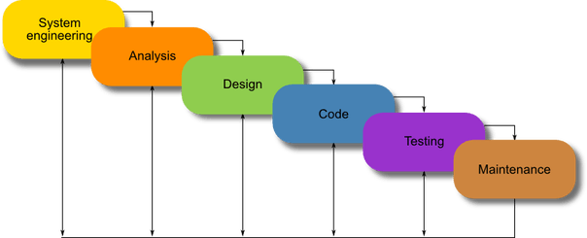

Figure 1: Waterfall Model

The waterfall model represents a linear and step-by-step strategy for software development where each phase must be finalized before proceeding to the next. Each stage of this approach is characterized by clearly defined inputs, outputs, and review mechanisms. The software development stages according to this model include conception, initiation, analysis, design, construction, testing, implementation, and maintenance.
One of the most significant benefits of the waterfall method lies in its simplicity and effectiveness. It is easy to understand, making it a great model for smaller projects. Additionally, it assures the completion of one stage before proceeding to the next, thereby reducing the potential for confusion or overlap. Apart from offering a clear framework and plan, the waterfall model facilitates efficient project management.
However, the inflexibility of the waterfall model stands as one of its major disadvantages. Once a phase is finished, it doesn't allow for modifications or revisions, which could be a considerable drawback if changes are needed later in the project. Moreover, the comprehensive documentation required at each stage can be expensive and time-intensive. Owing to the sequential nature of the phases, the model might also lead to a prolonged development cycle, thereby escalating costs and delaying market entry.

2.3.2 Agile Model
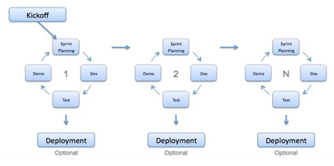
Figure 2 : Agile Model
Agile is a cyclic software development method that prioritizes adaptability, teamwork, and customer satisfaction. It's a preferred alternative to the traditional Waterfall approach as it enables constant feedback and modification throughout the development process.
The capacity to make changes and adjustments throughout the development phase is a key advantage of Agile, making it particularly beneficial for innovative or complex projects.
- Agile promotes communication and cooperation among team members, fostering improved collaboration and faster problem-solving.
- Customer Satisfaction: Agile methodology focuses on fulfilling customer needs, which can enhance customer satisfaction and deliver a higher-quality final product.
- Early delivery of functioning software: Agile methodology promotes early delivery of functional software in smaller segments, aiding in early issue detection and expedited deployment.
However, Agile methodology also presents some challenges:
- Lack of structure: Agile methodology can be less structured than traditional methods, which might not be suitable for all teams or projects.
- Due to Agile's iterative nature, project timelines and outcomes may be more unpredictable.
- Agile puts significant emphasis on customer involvement and feedback, which may not be possible for all projects or clients.
- Difficulty in measuring success: With Agile's focus on delivering functional software in smaller segments, evaluating progress can be tricky and necessitates different metrics than traditional methods.

2.3.3 Prototyping Model
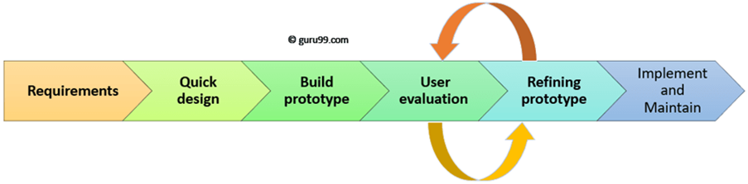
Figure 3 Prototyping Model
The prototyping model is a method employed in software development, characterized by the creation of a functional prototype of the planned system at the beginning of the project. This prototype is continually improved upon through iterative feedback and testing. This method allows for early detection and rectification of design shortcomings and functional problems. It encourages active participation and input from the client or end-user and supports flexibility and adaptation. Additionally, it provides a tangible representation of the product. In conclusion, the prototyping model is adept at delivering a product that aligns with the client's needs while reducing the likelihood of mistakes and unnecessary revisions.

2.3.4 Spiral Model

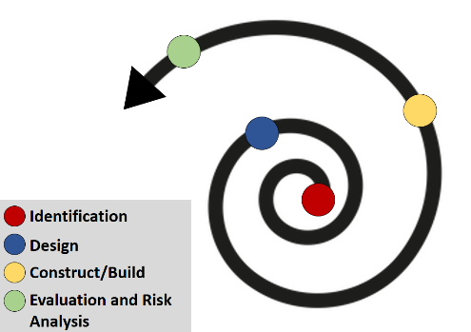

Figure 4: Spiral Model
The Spiral Model is a software development technique that blends the Waterfall and Iterative models' characteristics. It was established to counter the shortcomings of the Waterfall model, offering a more adaptable approach to software creation. Each round of the model involves phases of risk analysis, planning, execution, and assessment. The Spiral Model underscores risk control and supports frequent feedback and iteration, thus making it the method of choice for complicated projects.
The Spiral Model stresses risk management across all development stages. This enables early detection and alleviation of potential risks, leading to a more dependable and steady software product.
• The Spiral Model exhibits high flexibility and is responsive to changing project requirements. It enables continuous feedback and iteration, empowering the team to make necessary adjustments.
• The Spiral Model promotes user engagement and feedback throughout the whole development process. This ensures that the end product aligns with the user's needs and expectations.
• The Spiral Model offers a systematic approach to development, resulting in a superior final product. Each iteration includes testing and evaluation to ensure that issues are discovered and rectified before proceeding to the next stage.
• However, the Spiral Model may be more intricate and difficult to manage compared to other development strategies. Detailed planning and coordination are necessary to ensure the successful completion of each cycle.
• The Spiral Model could demand more resources and time compared to other methods. Each cycle requires a comprehensive round of planning, execution, and evaluation, which can be resource-intensive and time-consuming.
• Compared to other methodologies, the Spiral Model might be less predictable. Regular feedback and iteration might lead to changes in the project's scope and requirements, making it challenging to predict the final outcome.
• For effective application of the Spiral Model, a high level of expertise is necessary. Implementation might be complex for inexperienced teams or individuals lacking a thorough understanding of the process.
Implementing a prototyping model for the Online Doctor Appointment System (ODAS) project could have several advantages. Firstly, it would facilitate early detection and resolution of any design or functional issues, ensuring that the platform is efficient and user-friendly. Secondly, the iterative method would allow for continuous refinement of the platform based on user feedback, resulting in a product that satisfies the requirements of both patients and healthcare professionals. Lastly, the prototyping model would promote greater adaptability and flexibility throughout the development process, enabling quick and efficient modifications if needed. In essence, the use of a prototyping model would help guarantee that ODAS offers an effortless and convenient user experience, providing patients with unparalleled access to healthcare and enhancing the overall quality of life for people globally.

Chapter 3: Technical background
The chapter on technical foundation is an essential component of an online doctor’s appointment This chapter describes the technical requirements for each component of the system, including the hardware and software. In addition, it describes the various algorithms utilised to identify and recognise features. In addition, the chapter discusses the programming languages, databases, and frameworks utilised in the creation of the system. This section provides a comprehensive overview of the required technology and infrastructure for an effective Online Doctor’s Appointment system.

Hardware Components:
The Online Doctor Appointment System (ODAS) is heavily reliant on both client-side (user's computer) and server-side (cloud server or physical server) hardware for smooth operations.
On the client-side, users need a computer with a decent processor and ample memory to ensure the smooth running of the application. The specific hardware requirements would vary depending on the complexity of the web application, but at a minimum, the user's computer should have a stable internet connection and a modern web browser.
On the server-side, the system needs a robust server to process requests from users efficiently and to securely store user data. The server should have a fast processor, sufficient RAM, and ample storage space to manage the application's workload. This server could be a physical server located at the healthcare provider's premises or a cloud-based server provided by a third-party company. The latter is becoming increasingly popular due to its scalability and reduced maintenance requirements.
In addition, the server must have stringent security measures in place, including firewalls, intrusion detection systems, and encryption, to protect sensitive patient information and comply with healthcare data regulations.

Software:
In the Online Doctor Appointment System (ODAS), Django and Google SMTP play crucial roles in the software infrastructure. Django is a high-level Python web framework that enables rapid development and clean, pragmatic design. It is used in the development of the ODAS for its simplicity, flexibility, and robustness. Django is also known for its built-in features that include user authentication, a powerful ORM (Object-Relational Mapper) for database interaction, and automatic admin interface.
Google SMTP (Simple Mail Transfer Protocol) is used for the system's email functionality. SMTP is a communication protocol for electronic mail transmission. It's commonly used to send notifications or updates to users, such as appointment confirmations, password reset links, and reminders. Google's SMTP server is widely used due to its reliability and ease of integration with web applications.
Together, Django and Google SMTP form a part of the software infrastructure of the ODAS, helping to create a seamless and user-friendly online doctor appointment booking experience. It's worth mentioning that the ODAS may use other software components as well, depending on its specific features and requirements.

Programming languages:
Django is a Python-based web framework that follows the Model-View-Controller architectural pattern. It's used to develop robust, scalable, and maintainable web applications rapidly. Django is favoured in the development of the Online Doctor Appointment System (ODAS) because of its numerous out-of-the-box features such as its Object-Relational Mapping (ORM) system for database operations, automatic admin interface, and built-in support for user authentication.
In the context of ODAS, Django facilitates the creation and manipulation of models that could represent different components of the system such as patients, doctors, appointments, etc. It also allows the easy handling of HTTP requests and responses, session management, and URL routing, making it an excellent choice for building complex web applications.
On the other hand, Google's Simple Mail Transfer Protocol (SMTP) server is used for sending emails. SMTP is a protocol for sending email messages between servers. Most email systems that send mail over the Internet use SMTP to send messages from one server to another; the messages can then be retrieved with an email client using either POP or IMAP.

PyCharm Code editor
PyCharm is a highly versatile Integrated Development Environment (IDE) tailor-made for Python programming. The 'Code with me' feature of PyCharm provides a significant advantage, particularly in the context of remote or distributed development teams. This feature enables real-time collaboration on code, allowing team members to work simultaneously on the same codebase regardless of their geographical location. As a result, PyCharm was chosen as the primary IDE for developing our Online Doctor Appointment System (ODAS).
This collaborative feature fosters effective team communication, enhances coding efficiency, and allows for instant troubleshooting. The shared development environment aids in the rapid resolution of coding issues and accelerates the development process. Alongside this, PyCharm provides a range of other features such as code auto-completion, syntax highlighting, error detection, and a comprehensive set of tools for debugging and navigation, all of which contribute to improving productivity and code quality in the project.
In summary, the choice of PyCharm as the primary IDE allows for a streamlined, efficient, and collaborative coding process for the development of ODAS.

Databases
Databases are integral to the Online Doctor Appointment System (ODAS). The system necessitates a database to store information such as user profiles, appointment details, doctor schedules, patient medical histories, and other related data. SQLite3 is the chosen database management system for the ODAS. SQLite3 is a self-contained, serverless, and zero-configuration database engine widely used in application development for storing and managing data. Being an embedded SQL database engine, it saves data to a single file in the host system, making it an excellent choice for applications like the ODAS, where the simplicity of the database is paramount.
SQLite3 offers several benefits including ease of setup and use, low memory usage, and impressive speed. Its lightweight and efficient nature make it suitable for storing user information and handling various data transactions required in the ODAS, such as creating, reading, updating, and deleting records. To summarize, SQLite3 provides a robust and efficient solution for managing and storing data for the ODAS, thereby facilitating a smooth and

Draw.io
Draw.io is an efficient tool for designing diagrams and flowcharts, scoring 3.7 in terms of user ratings. For systems like the Online Doctor Appointment System (ODAS), Draw.io can be used to outline its architecture, workflows, and data flows.
One of the significant advantages of using Draw.io for the ODAS is that it allows the developers and stakeholders to visualize the entire system's architecture and data flow. This helps in pinpointing any possible system issues and bottlenecks, ensuring all components of the system are effectively connected, and facilitating better understanding of the overall system.
Moreover, Draw.io aids in the planning phase, as it provides a platform to model the user journey, different use-cases, and interactions within the system. As a result, the planning and design of the system can be more accurate and detailed, leading to an improved implementation process.
In summary, Draw.io can play a crucial role in the development of the ODAS by providing a clear and comprehensive visual representation of the system's architecture, workflows, and data flows.

Git and GitHub
Git and GitHub could serve as invaluable tools in the development process of the Online Doctor Appointment System (ODAS). Git, a distributed version control system, enables developers to keep track of code changes and collaborate efficiently on a project. GitHub, a web-based hosting service for Git repositories, supplements this with additional features like issue tracking, pull requests, and project management tools.
Within the context of the ODAS, Git can be used to manage multiple versions of the codebase as the system evolves. It enables developers to create separate branches for distinct features or testing, merge changes when they are ready, and revert back to previous versions if necessary. This approach ensures the code remains operational and stable, and it also enhances collaboration among developers working on the project.
GitHub extends the capabilities of Git by offering a platform for hosting repositories, along with extra features such as issue tracking and project management tools. Through GitHub, developers can track bugs and issues, assign tasks, and collaborate on the development of new features. This facilitates a more organized development process and ensures issues are addressed promptly.
Moreover, using Git and GitHub can streamline the deployment of the ODAS. By maintaining a clean and well-managed codebase, developers can ensure a faster and smoother deployment process.
In summary, Git and GitHub can significantly simplify the development and deployment of the ODAS, thanks to their version control, collaboration capabilities, and project management features.

Chapter 4: Requirements
The requirements section of the report on the Online Doctor’s Appointment system is essential for defining the system's intended functionality and performance expectations. This chapter emphasises both functional and non-functional requirements.

Functional Requirements
Functional requirements are the functions that a system must perform to satisfy the user's demands. In the context of an Online Doctor’s Appointment system, these responsibilities include Login in with encrypted password, accurately detecting doctor’s availability, User friendly Chatbot and Email confirmation of booking and reminders. The chapter provides an exhaustive list of functional requirements, including the capacity to store and analyse vast quantities of data, such as user data and doctor data.

Non-Functional Requirements:
Non-functional requirements are crucial to the success of the system but are unrelated to its functionality. These attributes include efficiency, dependability, and safety. For example, the system must be able to support a large number of concurrent users, be accessible to users around-the-clock, and have safeguards in place to protect the confidentiality of user data. This chapter elaborates on non-functional requirements such as scalability, defect tolerance, and security.
In addition to functional and non-functional requirements, the requirements chapter includes user needs. These criteria emphasise the user's experience and include usability, accessibility, and training. For instance, the system must be user-friendly, have an intuitive user interface, and offer sufficient user training resources.

Data Protection:
The requirements chapter for the Online Doctor Appointment System (ODAS) also accounts for legal and regulatory aspects. This includes legal or regulatory requirements that the system must comply with, especially those related to data protection and privacy. For example, the system must adhere to the General Data Protection Regulation (GDPR) if it's deployed in the European Union, along with any other applicable data protection laws in other regions.
Data privacy is a critical factor in the design of any system that collects and stores personal information. Therefore, the requirements chapter must detail the data privacy standards that ODAS needs to fulfil.
Initially, the system needs to comply with all relevant data privacy laws and regulations in the region where it's deployed. This could involve the GDPR, the Personal Information Protection and Electronic Documents Act (PIPEDA) of Canada, or the California Consumer Privacy Act (CCPA) of the United States, among others. The system design should uphold the principle of data minimization, meaning it should collect and store only the essential amount of personal information required for its functions.
Furthermore, the system must ensure the confidentiality and security of the personal data it collects and processes. This requires implementing adequate technical and organizational measures to prevent unauthorized access, theft, and loss of personal data. This might entail setting up access controls to limit who can access the data, and employing strong encryption techniques to protect data both in transit and at rest.
Finally, the system must provide users with transparency and control over their personal data. This includes providing clear and concise privacy policies and obtaining their consent before collecting and processing their personal information. Beyond offering users the ability to view, correct, and delete their personal data, the system should ensure data is stored only for as long as necessary to fulfil the system's purposes.
In essence, data privacy is a key consideration in the development of the Online Doctor Appointment System, and the requirements chapter should delineate the exact data privacy standards that the system must meet. The requirements chapter provides a comprehensive overview of the necessary attributes the system should possess to meet user expectations and needs, thereby establishing a clear roadmap for its development.

Chapter 5: Design

System Flowchart for Registering Users
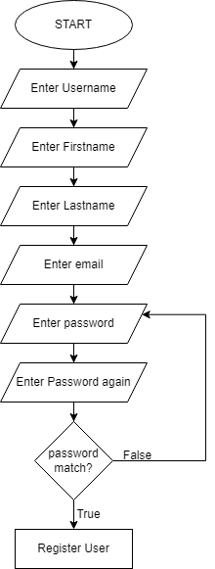

Figure 5 : System Flowchart for registering users
This flowchart outlines the user registration process for a system. The process begins at the start point, usually on a sign-up page, where the user is asked to input their chosen username, first and last names, and email address. Next, the user is prompted to choose and input a password, which they then have to confirm by entering it again. This step is crucial for securing the account as it will be needed for future logins. A check is performed to verify that the password and its confirmation match. If they match, the registration proceeds, and the user's details are stored in the system's database, thereby creating a new user account. If the password and its confirmation do not match, the system will prompt the user to re-enter their password, ensuring accurate input and validation during the registration process. This registration flow promotes a user-friendly experience while maintaining user data security.

Login Process
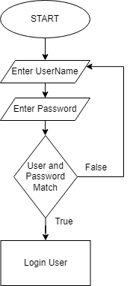
Figure 6: Flowchart Showing Login process
This flowchart illustrates the login process for a system. The sequence initiates at the start, usually on a login page. The user is asked to input their previously registered username and password. The system then checks whether the entered username and password correspond with the stored details in the database. If the entered credentials match the stored details, the user is granted access, completing the login process. However, if the entered username or password doesn't match the system's records, the user is prompted to re-enter their username and password again. This process helps in ensuring the security and authenticity of the user trying to gain access to the system, preventing unauthorized access.

Booking Process
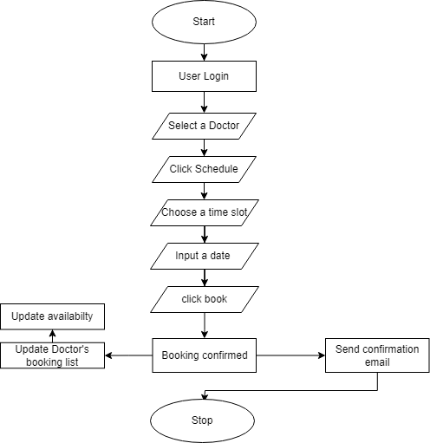
Figure 7: Flowchart showing booking process
This flowchart depicts the procedure for booking a doctor's appointment through the Online Doctor Appointment System (ODAS). The process starts with a user logging into the system. Once logged in, the user selects their preferred doctor from the available list. The system then displays the selected doctor's available time slots, from which the user chooses the most convenient one. Next, the user enters the desired appointment date. After these details are provided, the user clicks the "book" button to confirm the appointment. Upon successful booking, the system sends a confirmation email to the user. At the same time, the system automatically updates the doctor's time schedule to reflect the newly booked appointment and adjusts the doctor's availability accordingly. This process ensures efficient and accurate scheduling, allowing patients to book appointments seamlessly and doctors to manage their schedules effectively.

Chatbot Interaction
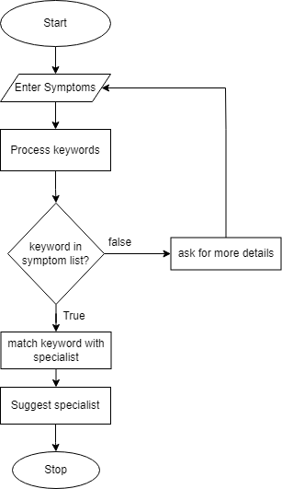

Figure 8: Flowchart showing Chatbot Interaction.
This flowchart describes the process of symptom-based doctor suggestion in the Online Doctor Appointment System (ODAS). The process begins with the user entering their symptoms into the system. The system then processes these inputs, searching for keywords that match with its predefined symptom list. If a keyword matches with the symptom list, the system links the identified symptom to a specialist doctor. The user is then provided with a suggestion for a relevant doctor based on their symptoms. However, if there is no match found in the initial input, the system prompts the user to enter their symptoms again. This interactive and responsive system helps guide patients to the appropriate healthcare professionals based on the symptoms they're experiencing.

Interface Design

Startup page:

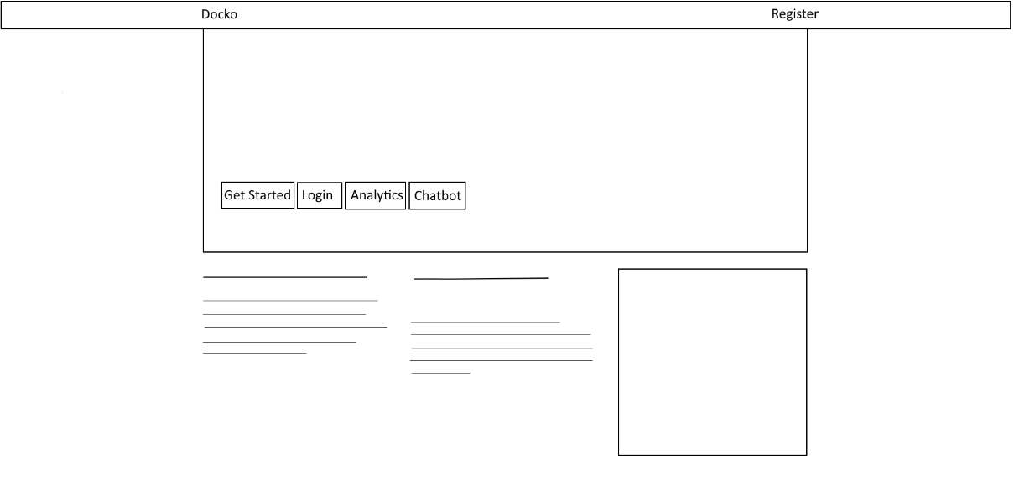
Figure 9: wireframe of Home Page
The provided wireframe showcases the home page of the system, featuring four main options: Register, Login, Analytics, and Chatbot. These options provide users with convenient access to the system's functionalities and services.
- Register: This option enables new users to create an account within the system. By clicking on the Register button, users can enter their personal details, such as name, email address, and password, to create their profile.
- Login: The Login option allows registered users to securely access their accounts. By clicking on Login, users can enter their credentials, such as username and password, to gain access to the system's features and services.
- Analytics: This option provides users with detailed analytics regarding the availability of doctors. By selecting the Analytics button, users can access information such as doctors' schedules, availability for appointments, and any additional data related to doctors' availability.
- Chatbot: The Chatbot option presents users with an AI-powered chatbot feature. By selecting Chatbot, users can engage in interactive conversations with the chatbot, which is designed to provide assistance, answer questions, and offer suggestions based on the user's needs and queries.
In addition to the main options, the home page wireframe indicates the presence of small articles. These articles are likely to provide users with additional information, tips, or insights related to healthcare, wellness, or other relevant topics. These articles can serve as a source of valuable information and engage users with relevant content.
Overall, the home page wireframe presents a user-friendly interface that offers essential functionalities like registration, login, analytics, and a chatbot, along with supplementary content in the form of small articles to enrich the user's experience within the system.

Register Page
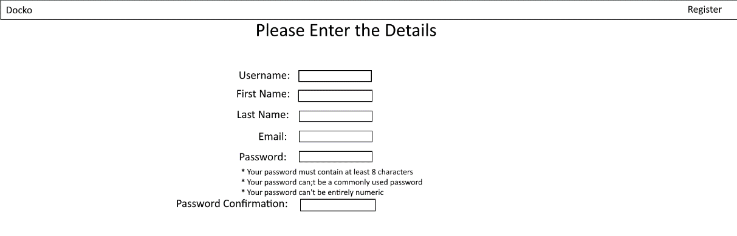

Figure 10: wireframe of main menu
The register page in the system serves the purpose of allowing users to create an account and register their details in the database. To successfully register, the user is required to input their desired username, first name, last name, email address, and password. Additionally, a password confirmation field is provided to ensure that the user accurately enters their password.
Once the user has entered all the required information, they can proceed with the registration process. The system will then store the user's details in the database, enabling them to log in with their chosen username and password in the future.
The registration page plays a crucial role in establishing user accounts within the system, facilitating secure and personalized access for users.

Login Page

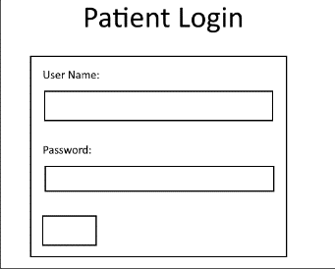
Figure 11: Wireframe of Login page
The login page is designed to enable users to access the web application by providing their username and password. Upon entering the username and password, the system verifies whether the entered credentials match the ones stored in the database. If the username and password are successfully authenticated, the user is granted access and is considered to have logged in successfully.
This login process ensures that only authorized users can access the web application, enhancing the security and privacy of user accounts and data. It allows users to access their personalized features, preferences, and information within the web application.

List of Doctors
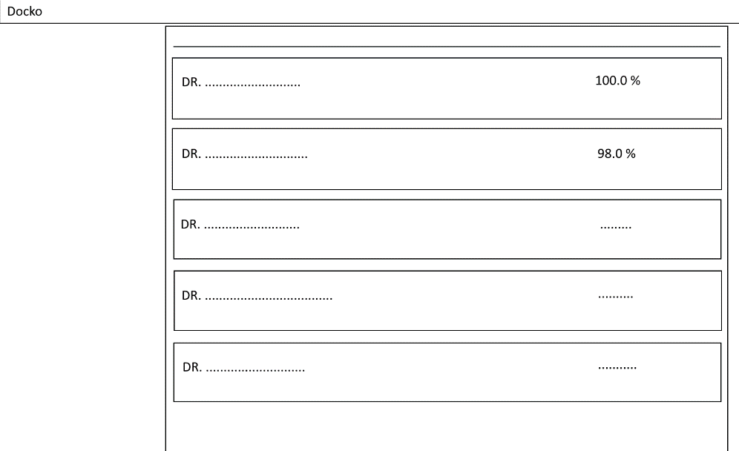
Figure 12: wireframe List of Doctors page
The list of doctor’s page displays a comprehensive list of registered doctors, along with their relevant details and availability. Users can browse through this list to find a doctor who suits their requirements. The details provided may include the doctor's name, specialty, experience, and any other relevant information.
Additionally, the availability of each doctor is represented as a percentage. This percentage indicates the doctor's current availability to accept appointments. It helps users assess the likelihood of securing an appointment with their desired doctor.
To proceed with the booking, users can click on the doctor's name or profile to view more information. This detailed view may include the doctor's available time slots, upcoming appointments, and any specific instructions or requirements for booking. Users can then select a suitable time slot for their appointment.
By allowing users to browse and choose their preferred doctor, the system enhances the user experience and provides flexibility in selecting healthcare professionals based on personal preferences and availability.

Doctor’s Details
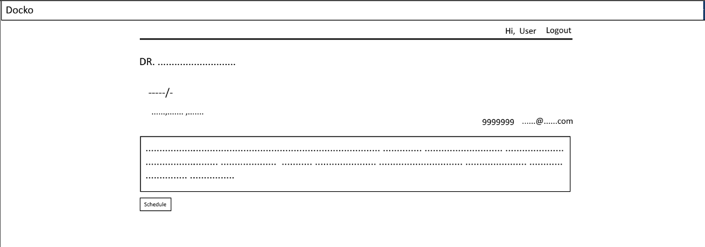
Figure 13: Wireframe of Doctor’s Details page
The doctor's details page provides users with comprehensive information about a specific doctor. It includes essential details such as the doctor's name, address, contact number, email, and a short description.
The purpose of this page is to help users make an informed decision when selecting a doctor. Users can review the doctor's profile, assess their qualifications, and get a sense of their expertise and specialization. Additionally, information about the doctor's location can assist users in determining proximity and convenience.
The doctor's pricing information may also be included, providing transparency regarding consultation fees or any other associated costs.
To proceed with booking an appointment with the doctor, users can simply click on the "Book" button displayed on the page. This action triggers the appointment booking process, allowing users to select an available time slot, provide any relevant details, and confirm the appointment.
By presenting comprehensive details and offering a convenient booking option, the doctor's details page streamlines the appointment booking process and assists users in making well-informed decisions about their healthcare choices.

Booking Page
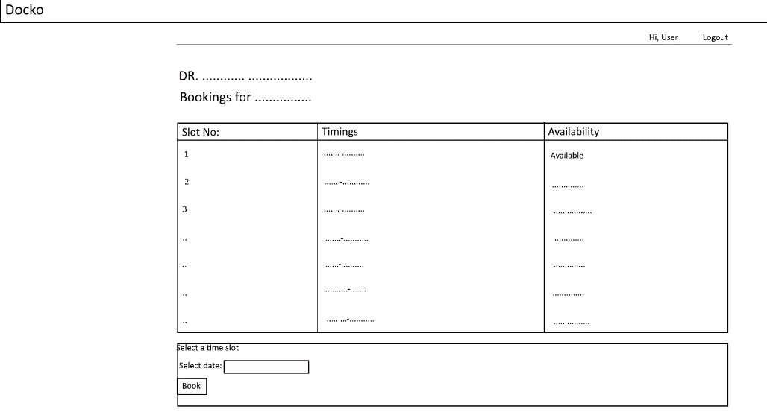
Figure 14: Wireframe for Booking page
The booking page provides users with specific details about the selected doctor and their available time slots. Users are presented with information such as the doctor's name, specialty, and any other relevant details. To proceed with the booking, users can select a suitable time slot from the available options displayed on the page. The time slots typically indicate the start time and duration of each appointment slot. Users can choose the time that best fits their schedule and preferences.
In addition to selecting the time slot, users are required to enter the desired date for the appointment. This allows users to book appointments for future dates based on their availability and the doctor's schedule.
Once the user has selected the desired time slot and entered the appointment date, they can click on the "Book" button to confirm the booking. This action finalizes the booking process, and the appointment is officially scheduled.
The booking page simplifies the appointment scheduling process by presenting the doctor's availability and allowing users to select a convenient time slot. It ensures that users can secure their preferred appointment time with the chosen doctor efficiently and effectively.

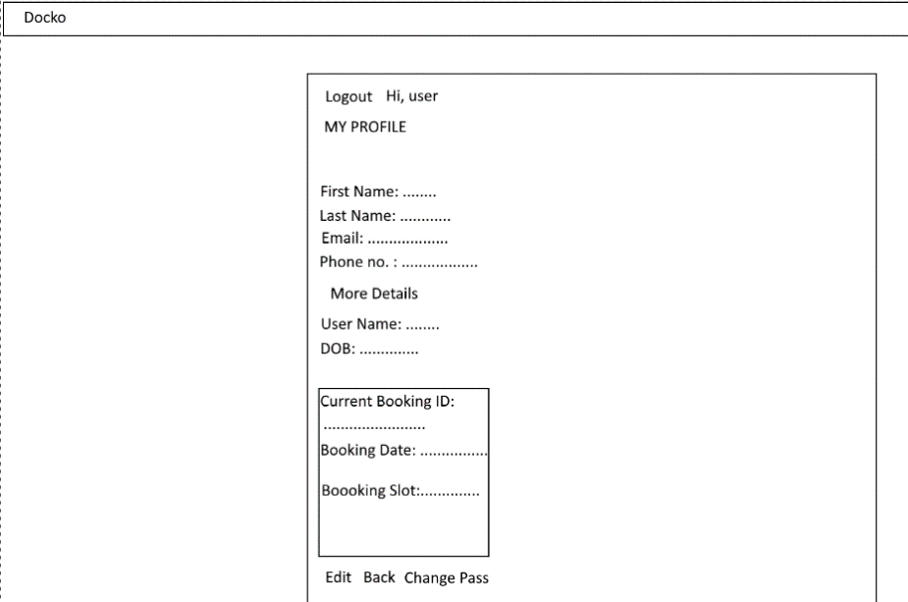
Profile page:
Figure 15: Wireframe for Profile page
The user profile page provides logged-in users with personalized information and options within the web application. It displays essential details about the user, including their first and last name, email address, and phone number.
In addition to the user's general information, the profile page also shows any current booking details if the user has made a booking with a doctor. This includes the booking ID, appointment date, and selected time slot. This information helps users keep track of their upcoming appointments and serves as a reminder for their scheduled visits.
Furthermore, the profile page typically includes a logout option. By clicking on the logout button, users can securely log out of their account, ensuring the privacy and security of their data.
The user profile page offers a personalized and convenient space for users to view and manage their account information, bookings, and logout functionality. It enhances the user experience by providing easy access to relevant details and actions specific to each user.

Analytics page
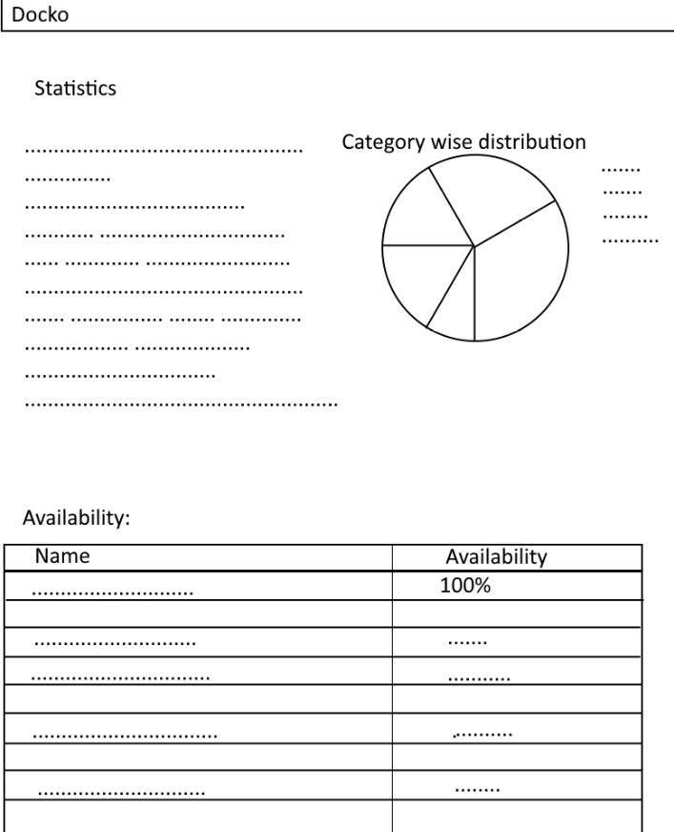
Figure 16: Wire Frame of Availability Page
In the availability page, the wireframe includes a pie chart depicting the current distribution of doctors in different categories. This pie chart visually represents the proportion of doctors available in each category, allowing users to quickly understand the distribution.
Below the pie chart, there is a list of doctors and their availability percentages. This list provides a detailed breakdown of individual doctors and their respective availability percentages. It enables users to view the availability of each doctor and make informed decisions when booking appointments.
The combination of the pie chart and the list of doctors' availability percentages offers a comprehensive overview of the current distribution of doctors across categories, allowing users to assess the availability of doctors and make appropriate choices based on their preferences and needs.

Chatbot Page
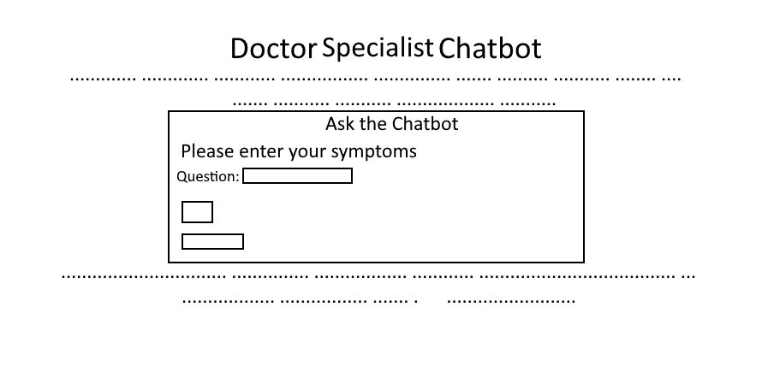
Figure 17: Wireframe of Chatbot Page
In the chatbot page, the user interface allows users to input their symptoms into a designated field. After entering their symptoms, users can click the "Ask" button to initiate the conversation with the chatbot.
Upon clicking the "Ask" button, the chatbot processes the user's input and generates appropriate responses based on predefined rules or patterns. The chatbot uses a rule-based approach to match the user's symptoms with predefined symptom-disease mappings or recommendations.
The chatbot does not employ a specific algorithm for symptom analysis or diagnosis. Instead, it relies on a set of pre-defined rules and mappings to provide suggestions or recommendations based on the symptoms entered by the user.
The goal of the chatbot is to offer initial guidance or suggestions to users based on their symptoms, helping them navigate the healthcare system more efficiently and directing them towards the appropriate specialists or medical professionals.
By utilizing this rule-based approach, the chatbot provides a user-friendly and interactive way for users to seek preliminary advice or recommendations based on their symptoms, facilitating the process of finding the right healthcare resources.

Chapter 6: Project Planning
Effective planning is crucial for any project, including the development of an online doctor’s appointment. It entails identifying the project's requirements, objectives, scope, and necessary resources, as well as establishing a timeline and budget. The planning phase begins with a thorough analysis of the requirements, followed by the formulation of a scope statement that outlines the project's goals. This scope statement serves as a foundation for creating a detailed project plan, encompassing timelines, budget allocation, resource management, and strategies for mitigating risks. Engaging project stakeholders is vital during the planning stage to ensure their needs are addressed and to gain their understanding of the project's objectives. Additionally, project managers should establish a comprehensive work breakdown structure (WBS) that outlines the tasks involved and assigns responsibilities to team members. Continuous monitoring and evaluation are crucial throughout the project's lifecycle to track progress, maintain adherence to objectives, and make necessary adjustments.

Resource Consideration
The development of a web application primarily requires minimal resources, focusing on the delivery aspect. The essential resource is a desktop or laptop computer with adequate processing power and memory to support the development and testing of the application. This machine serves as the primary tool for writing, executing, and testing the application's source code.
Apart from the hardware, various software tools are necessary to facilitate the development process. Fortunately, many of these tools are readily available online at no or low cost, making their acquisition affordable. These tools include integrated development environments (IDEs), code editors, version control systems, and testing frameworks.
While monetary resources are not the primary concern, the project will require a significant investment of time and effort. Developing a web application involves tasks such as requirement analysis, designing the user interface, writing code, testing, and deployment. These activities demand dedicated effort and expertise from the development team.
Overall, the primary resources for this project are a suitable computer system and the time and effort invested by the development team, while the associated software tools are generally accessible at a minimal cost.

Risk Assessment
A risk assessment for an Online Doctor’s Appointment system is as follows:
- Technical Risks:
There could be problems with the Booking system software that result in incorrect booking or false positives. This may result in delayed medical consultancy, which could compromise the system's integrity.
- Data leakage:
As Online doctor’s appointment systems rely on personal information, there is a possibility of data breaches or unauthorised access. User and doctor’s records and other sensitive data may be accessed and compromised by malevolent individuals.
- Privacy Threats:
If the system is not implemented properly, there is a chance that privacy rights will be violated. Personal information such as Name, phone number and email addresses may be collected without consent or retained for an extended period of time without encryption or security.
- Operational Risks:
Errors and malfunctions in the system may result in disruptions and delays in Booking. This may cause difficulty for the Patients, Doctors and Admin.
- Legal Risks:
The use of personal information may violate local or national privacy and biometric data laws. It is essential that the system adheres to all applicable regulations and policies.

Risk mitigations:
A number of potential risk mitigation strategies for the hazards previously cited include:
- System failure or malfunction: Regular backups and maintenance should be conducted to ensure data integrity and system stability. Testing and debugging procedures should be in place to identify and resolve any issues promptly. Implementing failsafe mechanisms and redundancies, such as backup servers or alternative communication channels, can help mitigate the impact of system failures.
- Unauthorized access to confidential information: Implementing strong password policies, including requirements for complex passwords and regular password updates, can help protect against unauthorized access. Two-factor authentication adds an additional layer of security. Encryption techniques should be employed to safeguard sensitive data. Access controls should be implemented to restrict user privileges and limit access to confidential information. Regular security audits should be conducted to identify and address vulnerabilities.
- Improper bookings and server issues: Using high-quality servers with sufficient capacity and reliability can minimize the risk of server-related problems. Implementing algorithms or validation checks within the system can help prevent improper bookings. Human verification or manual review processes can be put in place when necessary to ensure the accuracy and legitimacy of appointments.
- Data disclosures: Encryption should be applied to sensitive data to protect it from unauthorized access. Regular backups and maintenance should be performed to ensure data integrity and availability. Access controls should be implemented to restrict data access to authorized personnel. Monitoring tools can be employed to detect and respond to any potential data breaches. Routine security audits should be conducted to identify vulnerabilities and address them promptly.
- System failures and connectivity issues: Redundancies should be implemented to ensure system availability in case of failures. Routine maintenance and updates should be performed to keep the system running smoothly. Collaborating with trustworthy internet service providers and ensuring adequate infrastructure can help mitigate connectivity issues.
- Legal and moral issues: Compliance with applicable laws and regulations, such as data privacy and security regulations, should be ensured. Obtaining users' informed consent and providing transparency about data handling practices can help address ethical concerns. Regular evaluations of the system's ethical implications should be conducted to identify and mitigate any potential risks or conflicts.
By implementing these risk mitigation strategies, the Online Doctor's Appointment System (ODAS) can enhance data security, system reliability, and ethical compliance, minimizing potential risks and ensuring a secure and trustworthy platform for users.
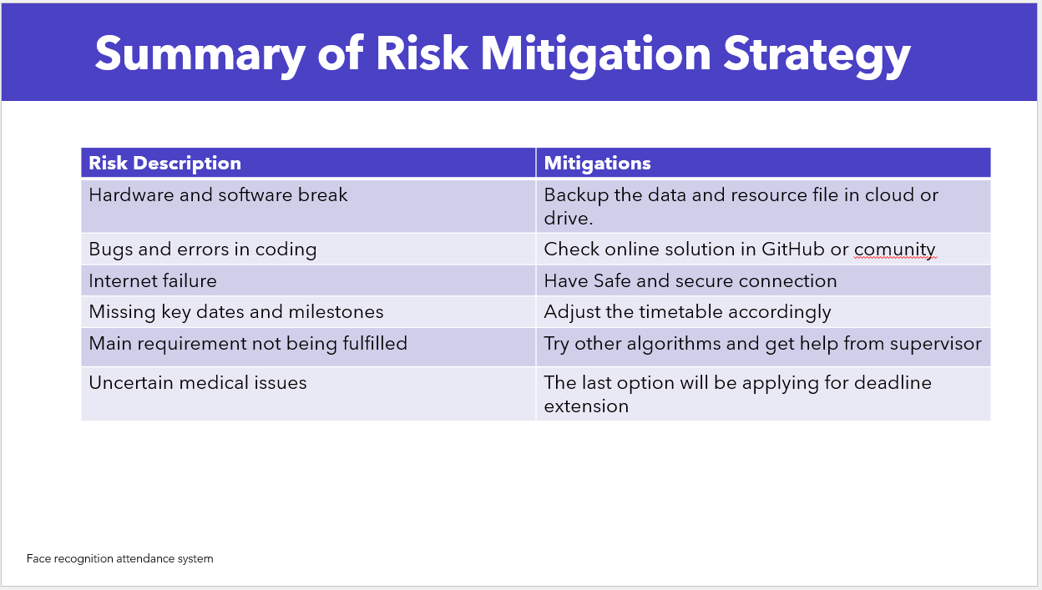
Figure 18: Table Showing Risk Mitigation Strategy

Gant chart
The Gantt chart for the online doctor’s appointment system comprises the following tasks and milestones:
- The objectives of the planning phase are to:
- defines the project's scope and requirements;
- identifies project team members and their responsibilities; and
- develops the project's timeline and milestones.
- Research and select appropriate framework
- Setting up the development environment
- Coding the software modules
- Testing and debugging the code
- Integrating the modules and testing the system

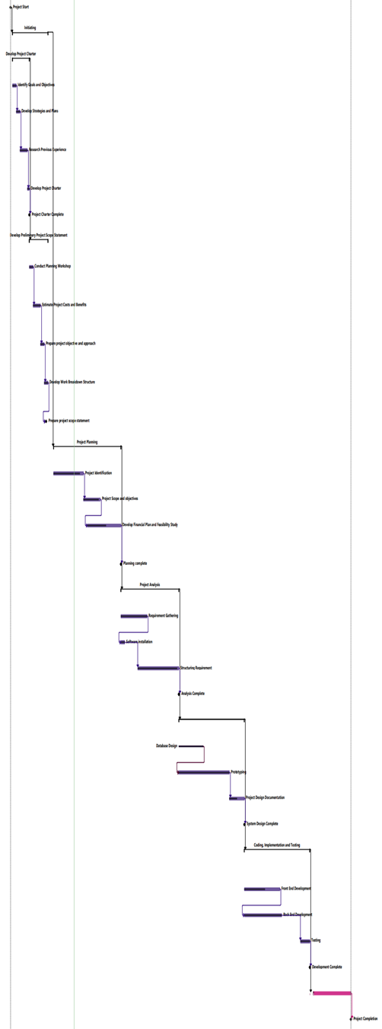
Figure 19: Gantt Chart
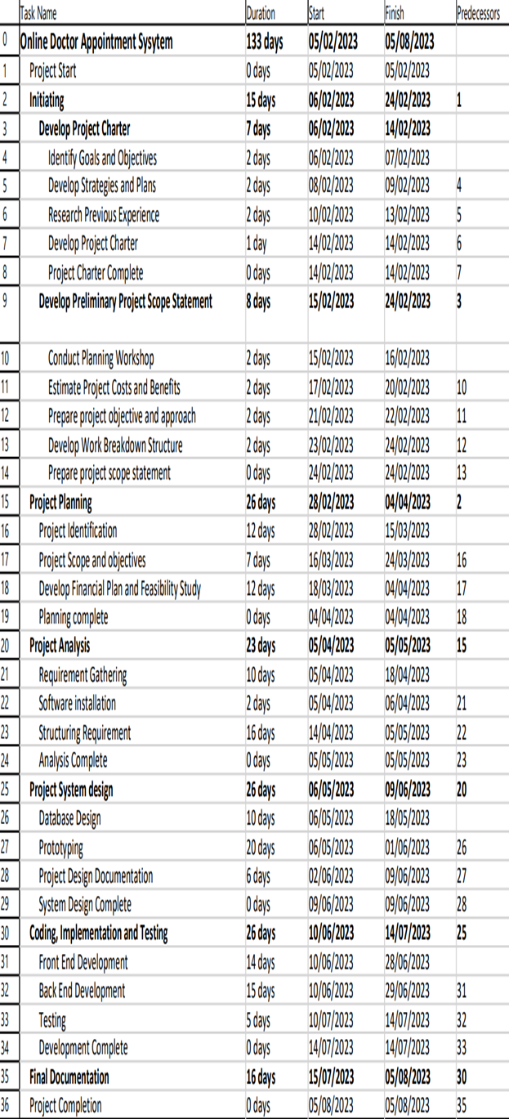
Figure 20: Image showing Time Schedule

Work Breakdown Structure

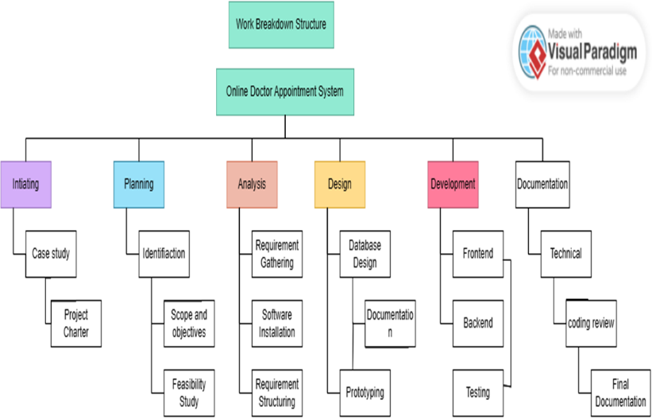
Figure 21: Image showing the work breakdown structure

Chapter 7: Implementation of the system

Working process of the project
The working process of the Online Doctor Appointment System (ODAS) can be broken down into three key components: the admin login, patient login, and chatbot feature.
- Admin Login:
The admin login allows authorized administrators to access and manage the platform's backend. This includes adding, deleting, and modifying doctor profiles and routines, as well as managing appointments and bookings. The admin interface ensures that the platform remains up-to-date and functions smoothly, providing an optimal user experience.
Key functionalities of the admin login include:
- Doctor management: Add, delete, or modify doctor profiles and their respective specializations.
- Routine management: Set and update doctors' schedules, including available time slots for appointments.
- Booking management: Oversee and manage appointment bookings, minimizing scheduling conflicts and ensuring a streamlined process for both doctors and patients.
- Patient Login:
The patient login enables users to create a secure, password-protected account where they can manage their personal information, medical history, and consultation records. Through their account, patients can view doctors' availability, book appointments, and access their consultation history.
Key functionalities of the patient login include:
- Personal information management: Securely store and manage personal details, including contact information and medical history.
- Appointment booking: Browse doctors' schedules, check availability, and book appointments at a convenient time.
- Consultation records: Access records of previous consultations, including doctor's notes and prescribed treatment plans.

- Chatbot:
The chatbot feature is an AI-powered tool that assists users in identifying the appropriate medical specialist based on their symptoms. By inputting their symptoms, users receive recommendations on which type of specialist to consult. This feature not only enhances the user experience but also streamlines the process of finding the right healthcare professional.
In summary, the working process of the Online Doctor Appointment System involves a combination of admin and patient logins, as well as a chatbot feature. The platform efficiently manages doctor profiles and schedules, provides a secure and convenient way for patients to book appointments, and assists in identifying the appropriate specialist based on user-inputted symptoms. This comprehensive approach ensures a seamless and accessible healthcare experience for all users.

Chapter 8: Testing and Evaluation
Testing is an essential component of developing the Online Doctor's Appointment System (ODAS) as it ensures the system's proper functionality and reliability in real-world conditions. For ODAS, testing involves evaluating various aspects such as user registration, login, appointment booking, and chatbot interactions.
To ensure the effectiveness of ODAS, a comprehensive set of test cases should be created and executed. These test cases should cover both positive and negative scenarios to validate different user interactions and system responses. Testing should also include scenarios with different user profiles, such as patients, doctors, and administrators, to assess the system's behaviour for different user roles.
Additionally, the system should be tested under different conditions, such as peak usage times or heavy user loads, to ensure its performance and scalability. The testing process should also involve checking for any potential security vulnerabilities and implementing measures to safeguard user data.
Once testing is complete, the collected data can be used to evaluate the system's performance, identify any issues or bugs, and make necessary improvements to enhance its overall quality and user experience.
Thorough testing of ODAS is crucial to ensure that it operates as intended, providing a reliable and user-friendly platform for users to book appointments and interact with the chatbot effectively.

Test case 1:
Admin Side
Follow these procedures to perform the test for invalid login (administrator side):
1. Navigate to the admin side's login page.
2.Input the username for the administrator account.
Enter an invalid password (such as "wrongpassword").
4. Select the "Login" link.
5. Verify the expected result:
- Confirm that the login attempt failed and the user is not currently signed in.
- Confirm that the message "You have entered an incorrect password" appears in a pop-up window.
If the actual output corresponds to the expected output, the test passes. If not, the test has failed, and further investigation is required to ascertain why.
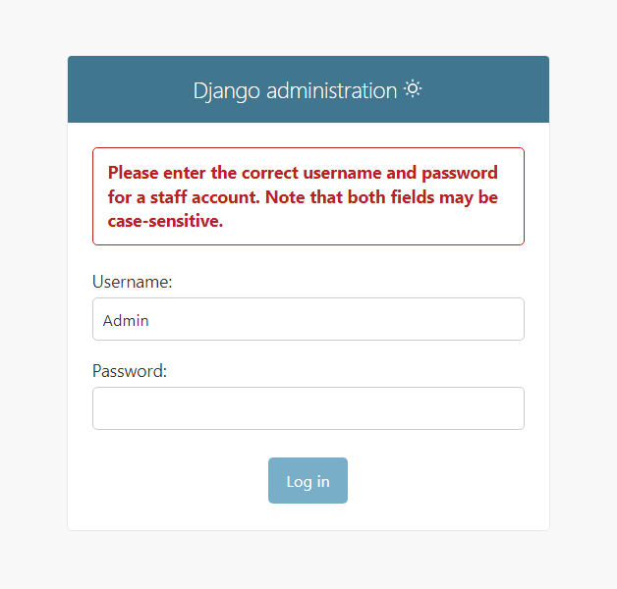
Figure 22: Test case 1 result

Test Case 2:
Objectives: Validate the Login (Admin Side).
Test Data:
UserName: Admin
- Secret: Root
Expected Outcome: - Successful logon and Admin page redirection
Test Steps:
- Launch the ODAS web app.
2. Navigate to "Admin Login" link.
3. Type "Admin" and “Root” into the Username and password field.
4. Select the "Login" link.
Ensure the user is redirected to the Admin Page.
Verify that the user has access to all administrative functions.
Test Outcome: Pass

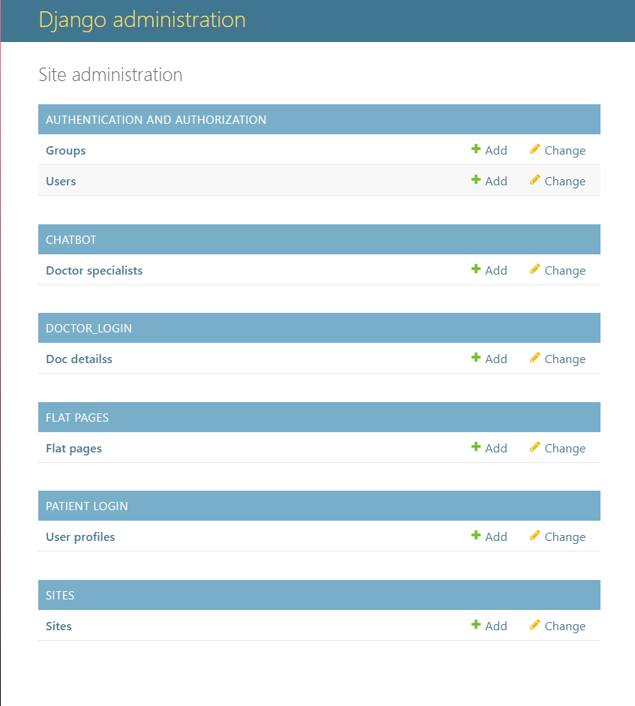
Figure 23: Test case 2 result

Test Case 3:
Test Objectives: Validate Registration (User Side).
Test data:
- Username: Pradip1–
First Name: Pradip
Last Name: Chettri
Email: pradipchhetri897@gmail.com
Password: ..99June26@
Steps:
- Launch the ODAS Web App.
- On the homepage, click the "Get Started" link.
- Enter "Pradip1" into the Username field.
- Insert "Pradip " into the First Name field.
- Insert “Chettri” into the Last Name field.
- Insert “pradipchhetri897@gmail.com” into the email field.
- Insert “..99June26@” into the password field.
- To Register, click the "Register" icon.
- Await the completion of the registration procedure.
- Verify that a text box with the message "Successfully registered " appears and redirects to Login page.
Expected Results:
- The application should effectively register the given username, first name, last name and email, for the user.
The message " successfully registered successfully" should appear in the login page.
Test Outcome: Pass

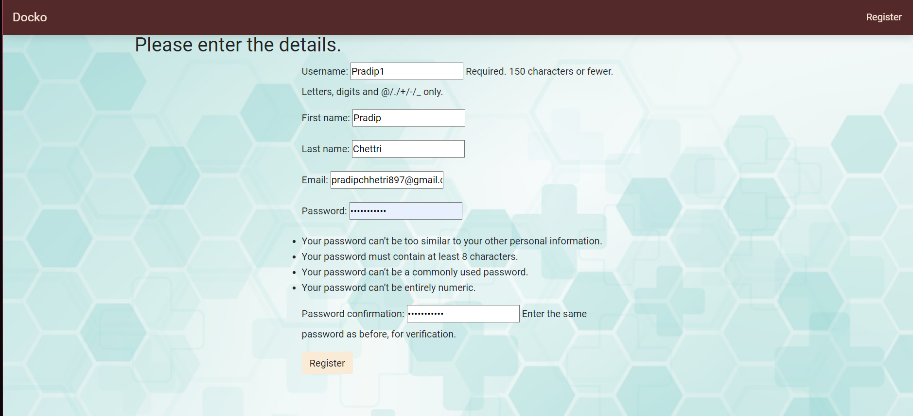
Figure 24: Test case 3 Result 1
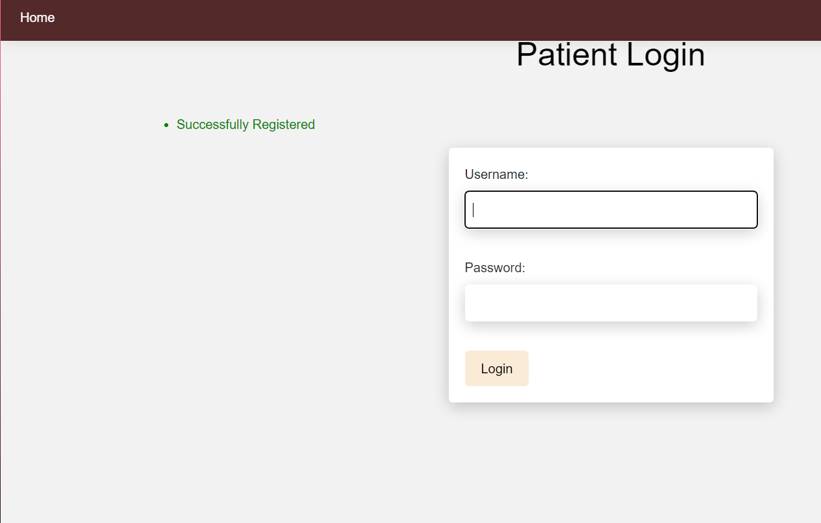
Figure 25: Test case 3 Result 2

Test Case 4:
Test Objectives: Validate Login (User Side).
Test data:
- Username: Pradip1–
Password: ..99June26@
Steps:
- Launch the ODAS Web App.
- On the homepage, click the "Login" link.
- Enter "Pradip1" into the Username field.
- Insert “..99June26@” into the password field.
- To Login, click the "Login" icon.
- Await the completion of the Login procedure.
- Verify that a text box with the message "Successfully registered " appears and redirects to Login page.
Expected Results:
- The application should effectively Login with the given username and password, for the user.
- The user should be redirected to the list of doctor page.
Test Outcome: Pass

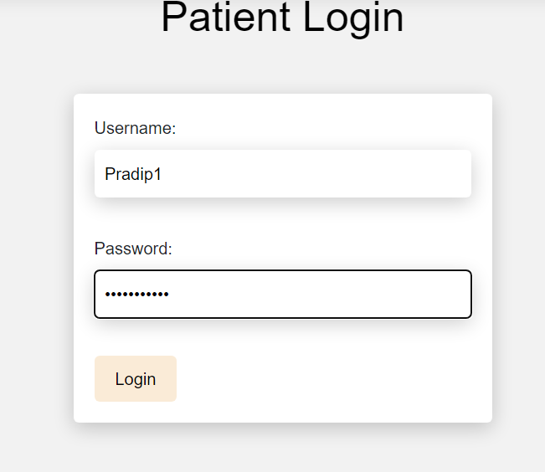
Figure 26 : Test Case 4 Result 1
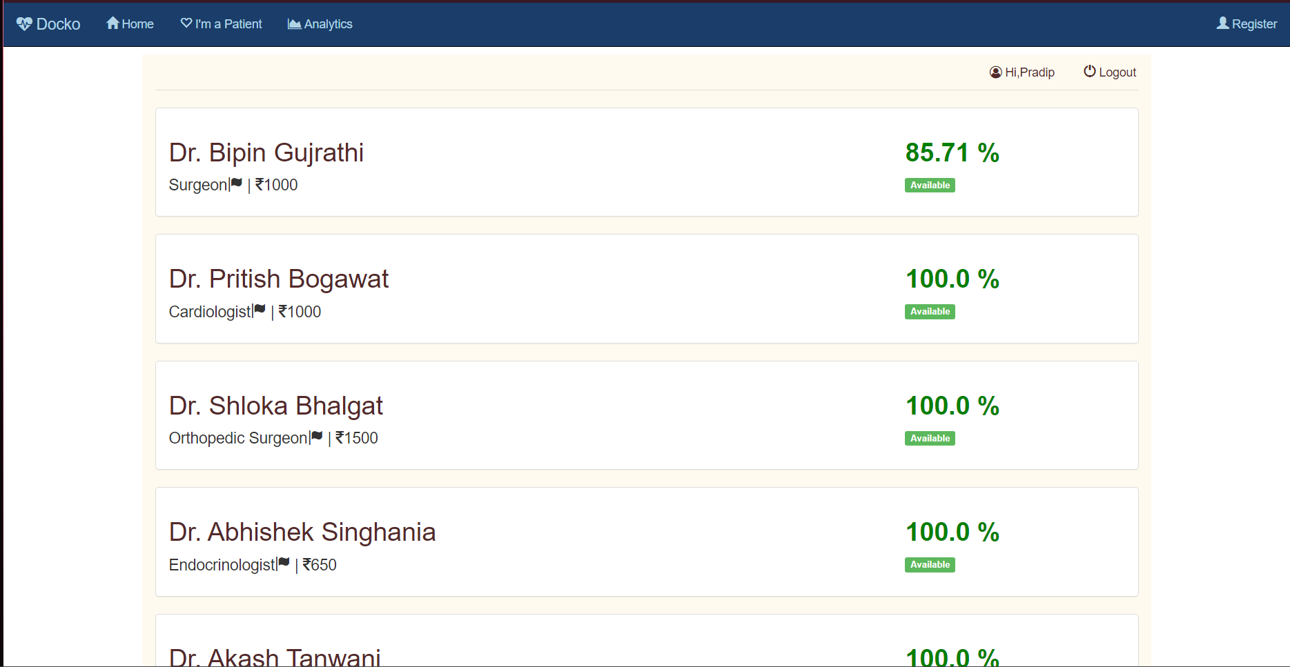

Figure 27: Test case 4 Result 2

Test Case 5:
Test Objectives: Validate The booking.
Test data: - Logged in User
The system should be able to Book a doctor according to the selection of registered user and update the Real time availability of the doctor.
Procedure:
- Start the system and log in with a registered user.
- The system should automatically redirect the user to the list of doctors available.
- Each registered pupil should individually select the doctor they want to book.
- The system should reliably give information about the doctor and time schedule.
- If an unregistered individual tries to login, the system should not log them into the system.
- Verify that the booking is confirmed.
- All registered users booking records should be accurately maintained.
- Booking records in the database must be precisely updated.
Fail Criteria:
- The system cannot precisely book the doctor.
- The database record is inaccurate.
Expected Results:
- The system should be Book the doctors selected by the registered users and update the availability of the doctors.
Test Outcome: Pass

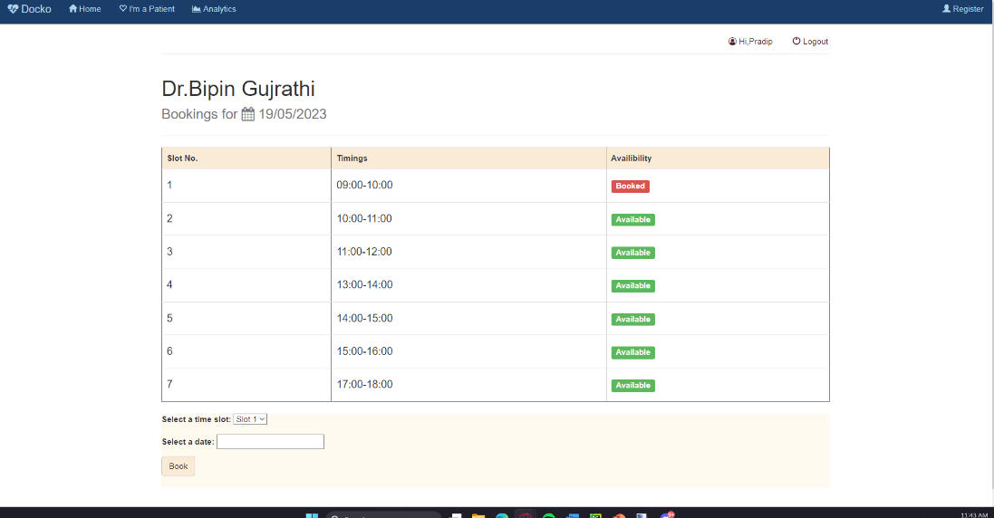
Figure 28: Test case 5 Result 1
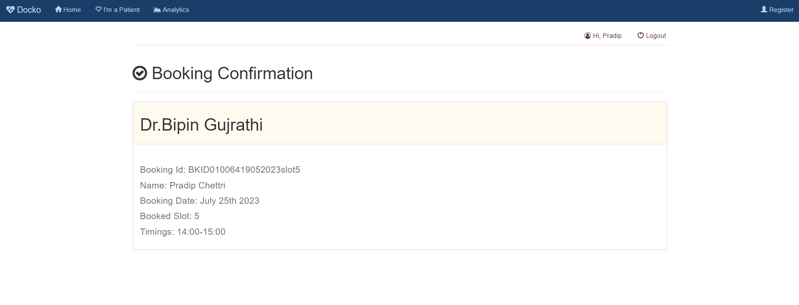
Figure 29: Test Case 5 Result 2

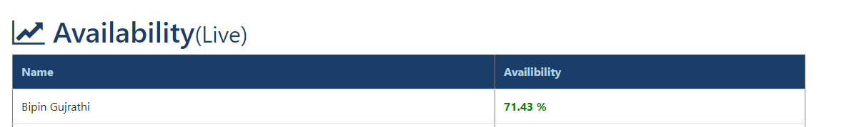
Figure 30: Test Case 5 Result 3

Test Case 6:
Test Objectives: Verify the Email Confirmation.
Test Data:
Registered user- Pradip1
Email: pradipchhetri897@gmail.com
Test Steps:
1. Login to the Web App
2. Book the Doctor according to the needs.
3. Confirm that the system is able send email confirmation to the emails of the registered users.
Expected Results:
- The system should be able to retrieve the emails of the saved users and send the confirmation id to the emails.
Test Outcome: Passed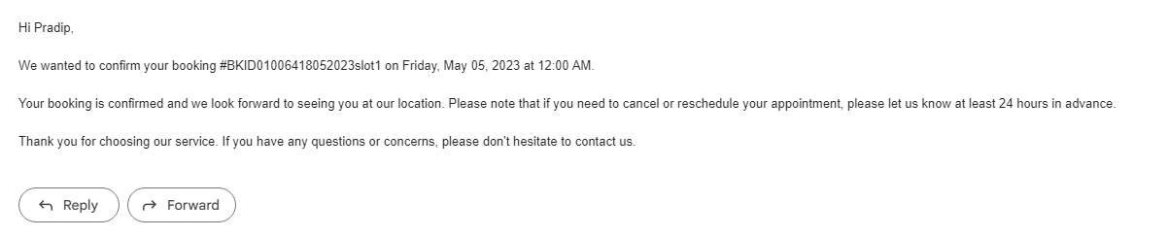
Figure 31: Test case 6 Results

Test Case 7:
Test Objectives: Verify the Email Reminders.
Test Data:
Registered user- Pradip1
Email: pradipchhetri897@gmail.com
Test Steps:
1. Login to the Web App
2. Book the Doctor according to the needs.
3. Confirm that the system is able send email confirmation to the emails of the registered users.
4. Expect a Email Reminder the day before the appointment
Expected Results:
- The system should be able to retrieve the emails of the saved users and send the email reminders to the emails.
Test Outcome: Passed
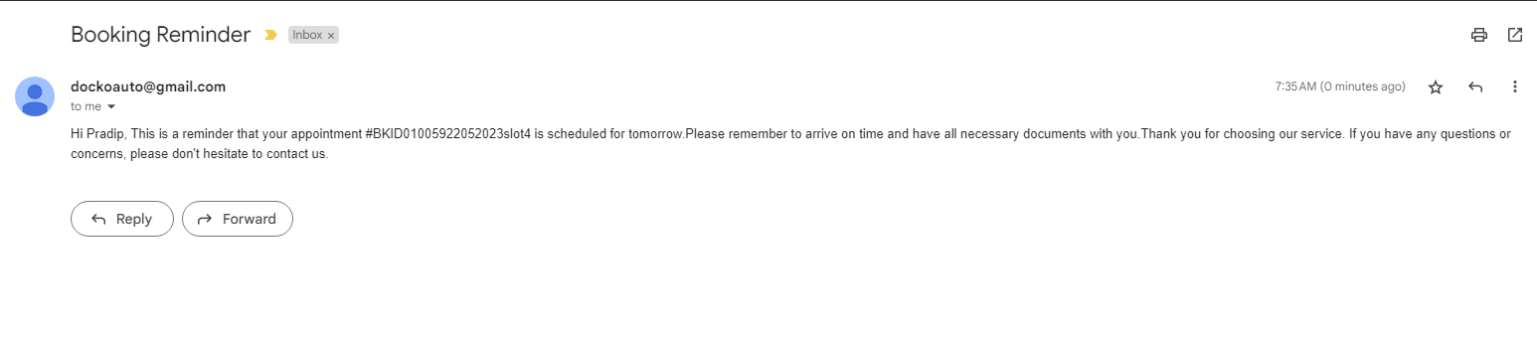
Figure 32 : Test Case 7 Result

Test case 8:
Test Case 7: Chatbot Verification Test
Objectives: Verify that the user can effectively use the Chatbot.
Test data:
• Symptoms: Jaw Pain
Steps:
1. Start the ODAS web app
2. Navigate to the Chatbot Application
4. Enter: “I have Jaw Pain”
5. Ensure that the chatbot replies with appropriate specialist.
Expected Results:
• The Chatbot Suggests a specialist based on the user’s symptoms.
Test Outcome: Passed

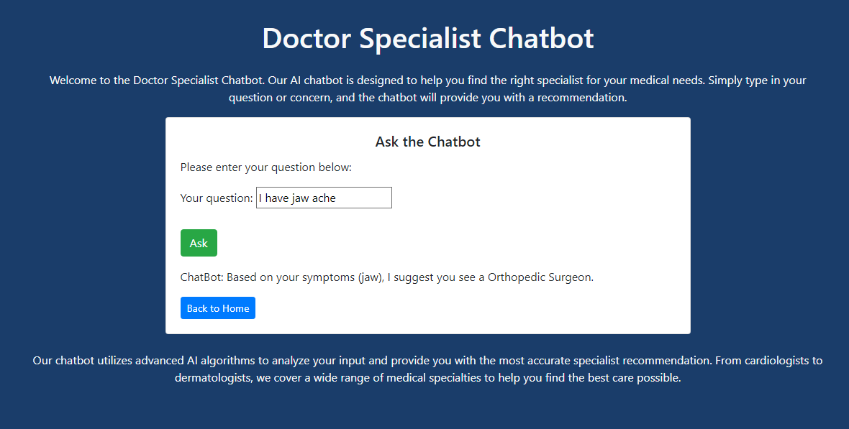
Figure 33: Test case 8 result

Chapter 9: Conclusion and future Recommendations

Critical analysis
Online Doctor Appointment System (ODAS) with real-time doctor's availability checking, email confirmations, reminders, and chatbot functionalities is a revolutionary tool that brings significant efficiency in the healthcare sector. It employs the Django framework, a high-level Python web framework that encourages rapid development and clean, pragmatic design.
The ODAS allows users to check doctor availability in real-time. This feature is indispensable in reducing waiting times and ensuring immediate care for patients. This is made possible by leveraging Django's ORM (Object-Relational Mapping) feature that abstracts the database layer and provides a convenient way to manage data.
Another integral part of the system is the feature of email confirmations and reminders. Once a patient makes an appointment, the system sends a confirmation email to them, ensuring the appointment is noted and reducing the chances of missed appointments. The system also sends reminders before the appointment date, enhancing the efficiency of the healthcare delivery process. The implementation of these features posed challenges due to Google's new regulations on SMTP, but with due diligence, the issues were resolved.
The ODAS is equipped with a unique feature, a chatbot, which suggests a specialist to the patients. The unique aspect of this chatbot is that it doesn't rely on complex machine learning algorithms but rather uses simple rule-based logic. Based on patient's inputs regarding symptoms or medical conditions, the chatbot suggests an appropriate specialist. Implementing this functionality was challenging, as chatbots usually rely on some form of machine learning or AI to function efficiently. However, by creating a well-structured rule-based system and using Django's robust functionalities, this was accomplished effectively.
Although the ODAS is fully operational and greatly beneficial, the development phase was not without issues. The major challenge encountered was figuring out how to implement the chatbot without using algorithms. Furthermore, complying with the new Google SMTP regulations for sending emails also posed some technical issues. However, with the power of the Python and Django community, these problems were overcome.
Like any robust system, the ODAS was developed with a combination of several tools and libraries. Python, with its vast library support and readability, was the core programming language used. Django, a powerful web framework for Python, was used for building the web application. Other libraries and tools used include Django's built-in libraries for managing database operations, SMTP library for sending emails, and rule-based systems for the chatbot functionality.
While the current ODAS is efficient and well-integrated, there is potential for further improvement. Plans for future enhancements include adding more interactive features to the chatbot and improving the email system to provide more personalized appointment details and reminders.
In conclusion, the ODAS is a powerful tool that streamlines the process of booking doctor appointments, thereby bringing in increased efficiency and user-friendliness in healthcare services.

Future Enhancements
In the realm of the Online Doctor Appointment System (ODAS), enhancing the chatbot's capabilities to a more sophisticated level can open up exciting new avenues for user engagement and efficiency. As we look forward to future enhancements, implementing a more complex algorithm in the chatbot feature within a mobile app environment can greatly improve the system.

References

[1] | J. E. &. C. B. G. Hollander, “Virtually perfect? Telemedicine for Covid-19,” New England Journal of Medicine, vol. DOI: 10.1056/nejmp2003539, 2020.
[2] | E. R. &. T. E. J. Dorsey, “State of Telehealth.,” New England Journal of Medicine. , no. DOI: 10.1056/nejmra1601705, 2016.
[3] | World Health Organization., “Telemedicine: opportunities and developments in Member States,” 2010.
[4] | “About PYthon,” Python.org, [Online]. Available: https://www.python.org/about/. [Accessed 2023].
[5] | “Django Overview.,” DjangoProject, [Online]. Available: https://www.djangoproject.com/start/overview/. [Accessed 2023].
[6] | “Python in Healthcare.,” University of Illinois Chicago, [Online]. Available: https://healthinformatics.uic.edu/blog/python-in-healthcare/.
[7] | NHS, “About the National Health Service (NHS) in England,” 2023. [Online]. Available: https://www.nhs.uk/nhs-services/. [Accessed 2023].
[8] | MyChart, “Epic: MyChart - Login Page,” 2023. [Online]. Available: https://www.mychart.com/. [Accessed 2023].
[9] | GP at Hand, “GP at Hand,” 2023. [Online]. Available: https://www.gpathand.nhs.uk/. [Accessed 2023].
[10] | eConsult, “eConsult,” 2023. [Online]. Available: https://econsult.net/. [Accessed 2023].
[11] | Push Doctor, “See a doctor in minutes,” [Online]. Available: https://www.pushdoctor.co.uk/. [Accessed 2023].
[12] | Doctorlink, “Healthcare, Connected,” 2023. [Online]. Available: https://www.doctorlink.com/. [Accessed 2023].
[13] | LIVI, “LIVI – See a Doctor by Video,” [Online]. Available: https://www.livi.co.uk/. [Accessed 2023].
[14] | Qured, “Qured: Doctors to your Door,” 2023. [Online]. Available: https://qured.com/. [Accessed 2023].

